NBC

Northwood Badminton Club Newsletter
November 2005

So far the season has kicked off to a great start with many members (new and old) getting involved in the regular club night and also helping to make our very busy fixture list achievable.
This year we have a total membership of 44, with 31 male members and 13 ladies. Not only have we grown in junior members but we have also significantly increased our numbers of ladies. So ladies, keep coming so we can have a ladies court running all night!

A big welcome to all new members and rejoiners:

Juniors: Seniors:
Yasmin Branch-Amory Sharon Fidler
Elleisha Chahal Raj Hindocha
Melissa Diong Anna Lee
Sarah Furzer Prakash Panikker
Peter Su
Neil Webb
Andrew Wood
Rick Yang


NBC thirtieth birthday celebrations:

“The London Badmintonathon”
The “Badmintonathon” event organised to celebrate Northwood Badminton
Club’s thirtieth birthday was a fantastic success. With the support of many people who came along and played at some very odd times of the day and night, we managed to keep the shuttle in continuous play for 50 hours, a truly astonishing accomplishment.
This challenge, never before undertaken, meant that we raised over £3,000 for the charity “Help a London child”, which will go towards aiding under-privileged children in London.
Members and non-members alike dressed up in PJs for night time play and during Saturday, young and old participated in the Generations Tournament, after this, everyone enjoyed watching the spectacular exhibition singles match between Aamir and Rajiv. On Sunday there was an opportunity for all to have some coaching with Lee Jae Bok and we finished the day with a “Fast and Furious tournament” to wind down!
Aside from the competition winners, extra special congratulations go to Daryl Jacobs and Robert Kettle who almost managed to stay awake for the entire badmintonathon. It was enthusiasm and determination like this that made the event fun and successful.

Special thanks also go to the “Badmintonathon Committee Team” who made the entire massive event possible, so Jean, Joel, Nigel, Eddie and Malcolm thank you for all the time and effort you put in.

The event also marked the birth of the now extremely popular “NBC” t-shirt which was a huge seller over the 2 days and since. Please note if anyone didn’t manage to get one or wants another, the medium, large and extra large sizes are still available.

If you would like any further information regarding the event-please visit our website on: http://www.northwoodbc.uku.co.uk/

This Year’s AGM
The AGM this year was held at Nigel’s house. Unfortunately, we had a bit of a poor showing so please guys, next year, if you want your say, come along and get involved.
Sadly after many years as our club Chairperson, Nigel was unable to continue in this position due to a knee injury which will need to be operated on this year. Many thanks to Nigel for all the work and dedication he has put into the club over these years. Lesley was voted to chairperson of the club but this will be subject to her work schedule.

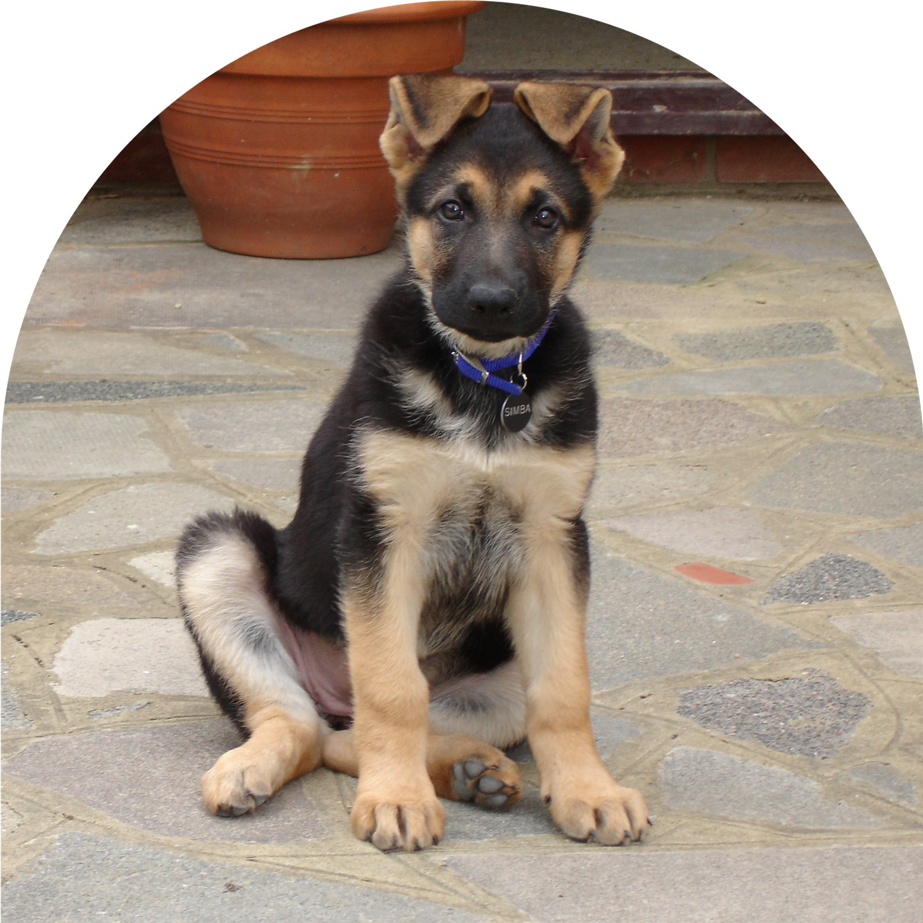
Club Mascots

We would all like to welcome the new club
Mascot “Simba”. She was born on 3 August and
subject to sports centre rules, she will soon be cheering us
on during our matches.

Jean has also recently acquired two rescue kittens, so I
hope all our club pets can be friends.

Social events coming soon-“The Christmas Party”

Eddie has already been investigating Christmas party venues and because this is indeed a busy social time, we need to book soon.
The favourite venue at the moment is “Quackers Riverside restaurant” in Uxbridge. A night here would mean we could enjoy a four course meal and dance until 1 am. The cost of this would be £24.90-Sunday to Tuesday and £29.90-Wednesday to Saturday.
Possible booking dates are either 5/6 or 7 December or 14/19 December.
Please let Eddie know as soon as possible which would be your preferred date or indeed if you know of any venues that could top this.

For further details, go to:
http://www.quackersriverside.com/index.html
Quackers Riverside
Old Mill Lane
Uxbridge
Cowley
UB8 2JH
Tel:
01895 237 559
01895 270 271

Suggestions for club night:

NBC is constantly striving to keep club nights exciting, fun and challenging for all members. We also know that the atmosphere and enthusiasm at club night is driven by you, so if anyone has any suggestions to keep this a fun and motivating night, please let any committee members know. These are the two Jeans, Malcolm, Lesley, Steve, Steve Jacobs, Eddie, Joel, Nigel and Debbie.

- One recent suggestion to liven things up is that we should also encourage club members with a club doubles ladder with matches being arranged in club sessions.

So guys let us know your thoughts and any ideas!

Written by Debbie Pearce

